Public Manual

Stakeholder Upload Platform
Document & Information Posting Guide
Version No. 3, 12/01/23
Table of Contents
Disclaimers 1
Document Change History 1
1. Introduction 2
1.1 Purpose of the Stakeholder Upload Platform 2
1.2 Reference & Important Webpages 2
2. Getting Started & Tool Overview 4
2.1 Register as a User 4
2.2 Request Access & Posting Privileges 5
2.3 Platform Menu Overview 7
3. Formula Rate Protocol Postings 8
3.1 Uploading Documents 8
3.2 Publishing Documents 10
3.3 Sending Notifications 11
3.3 Viewing Documents 12
3.4 Archived Documents 12
3.5 Downloading Files 13
3.6 Deleting Documents 14
4. Annual Informational Filings 16
4.1 Post a Docket Number 16
4.2 View Informational Filing History & Posting Status 17
5. Non-Protocol Postings 18
5.1 Request Document Posting 18
5.2 View Request History 18
6. Notification Requests 19
6.1 Notification Types 19
6.3 Notification Distribution 20
7. Manage Access 21
7.1 Request Access 21
Appendices 22
Appendix A: Subscribe to the Transmission Rate Notifications (TRN) Exploder List 23
Appendix B: Attachment O Formula Rate Protocols Background 25
Appendix C: Formula Rate Protocols - Standard Posting & Notification Timeline 26

Disclaimers
This reference is prepared for discussion and information purposes and provided "as is” without representation or warranty of any kind, including without limitation, accuracy, completeness or appropriateness for any particular purpose. MISO assumes no responsibility for the consequences of any errors or omissions. MISO may revise or withdraw this reference at any time at its discretion without notice. Though every effort will be made by MISO to update these references and inform its membership of changes, it is the user’s responsibility to ensure the most recent edition is being used.

Document Change History
Version | Reason for Issue | Date
1.0 | User guide created | 12/01/19
2.0 | Update for new document archiving feature | 07/20/23
3.0 | Update due to MISO website re-design | 12/01/2023

1. Introduction
This guide for the MISO Stakeholder Upload Platform includes basic information about the tool & its functionality. Section 1.1 describes the purpose of the platform and intended usage of the tool. Section 1.2 identifies basic resources for accessing the tool and helpful reference information.

Purpose of the Stakeholder Upload Platform
Registered users will access the portal for 2 primary purposes:
- To fulfil their Attachment O Formula Rate Protocol posting & notification requirements, as outlined in the MISO Tariff. Users can:
  - Request posting privileges to their transmission owner page(s) residing on the MISO public website (Transmission Owner Rate Data page)
  - Post materials to their TO page(s) on MISO’s public website and/or their OASIS. Based on the document type uploaded, this will also initiate any required notifications
  - View posting & notification details and manage their annual postings
- Submit requests for posting other materials to their OASIS page (NOT related to the requirements of the Attachment O Formula Rate Protocols)

Reference & Important Webpages

Transmission Settlements and Pricing (contains Formula Rate Compliance info)
https://www.misoenergy.org/markets-and-operations/settlements/ts-pricing/#t=10&p=0&s=&sd=

MISO transmission owner Rate Data Pages
https://www.misoenergy.org/markets-and-operations/settlements/to-rate-data/

MISO Stakeholder Upload Platform
https://misostakeholderuploadplatform.azurewebsites.net/Login

MISO transmission owner OASIS Pages
https://www.oasis.oati.com/miso_default.htm

MISO Tariff
https://www.misoenergy.org/legal/tariff/

2. Getting Started & Tool Overview

2.1 Register as a User

 Google Chrome is the recommended web browser for this tool.

To use the Stakeholder Upload Platform, users must be registered & have a profile setup on the MISO public website.
- Registered Users: Test your login on the MISO public website:
  - Navigate to https://www.misoenergy.org/
  - Select ‘Log in’ – top right of the page
  - Make sure you can login here first; if login doesn't work, you may need to reset your password (these expire every 45 days).
  - Registered users will use those same credentials to login to the Stakeholder Upload Platform.

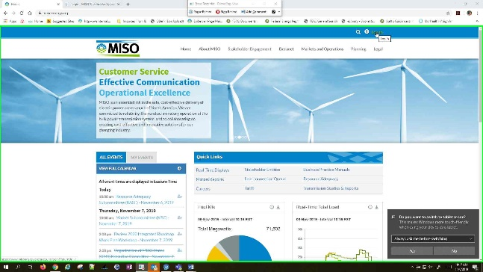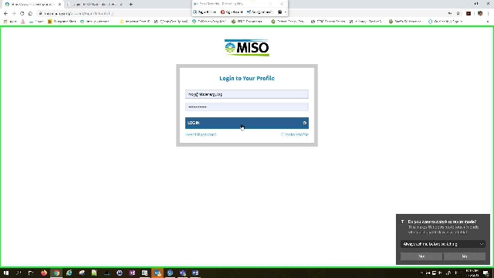

- If you do not have a profile setup on the MISO website, you’ll need to create one:
  - Navigate to the MISO website https://www.misoenergy.org/
  - Select ‘Log in’
  - Choose ‘Create Profile’; complete all required fields & select ‘Create Profile’
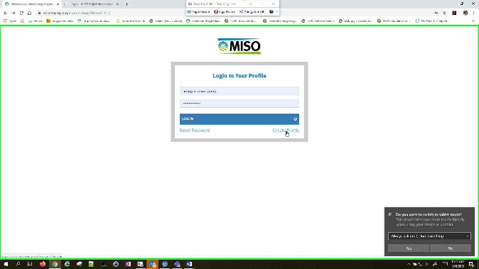

  - You should receive an email asking you to confirm registration; follow the link in the email to complete registration. (If you don’t see an email in your Inbox, check Junk/Spam folders to make sure it didn’t go there).
  - After you’ve confirmed registration, you can use those same login credentials to access the upload tool.

2.2 Request Access & Posting Privileges
To post documents to their MISO TO Rate Data page and/or OASIS, users must first request & be granted access to that transmission owner’s page.
 Users should only request access to entities which they are authorized to do business for (or on behalf of).
- Registered users of the MISO website login to the Stakeholder Upload Platform using those same login credentials
  - Access the link to the Stakeholder Upload Tool https://misostakeholderuploadplatform.azurewebsites.net/Login
  - Enter login credentials & click ‘Sign In’
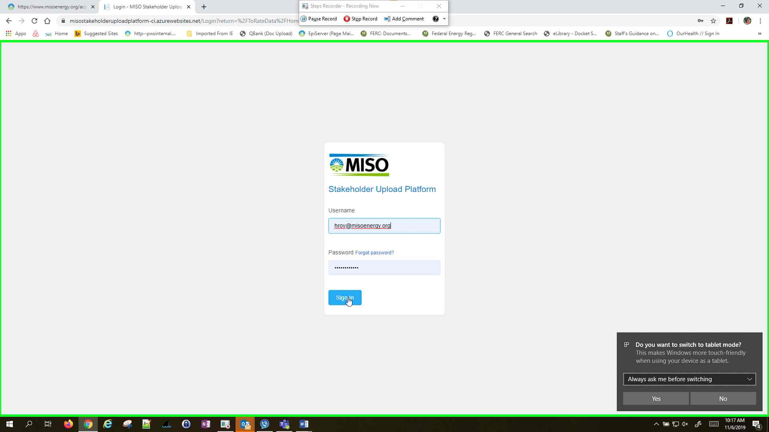

- Navigate to the ‘Manage Access’ section of the menu & select ‘Request Access’
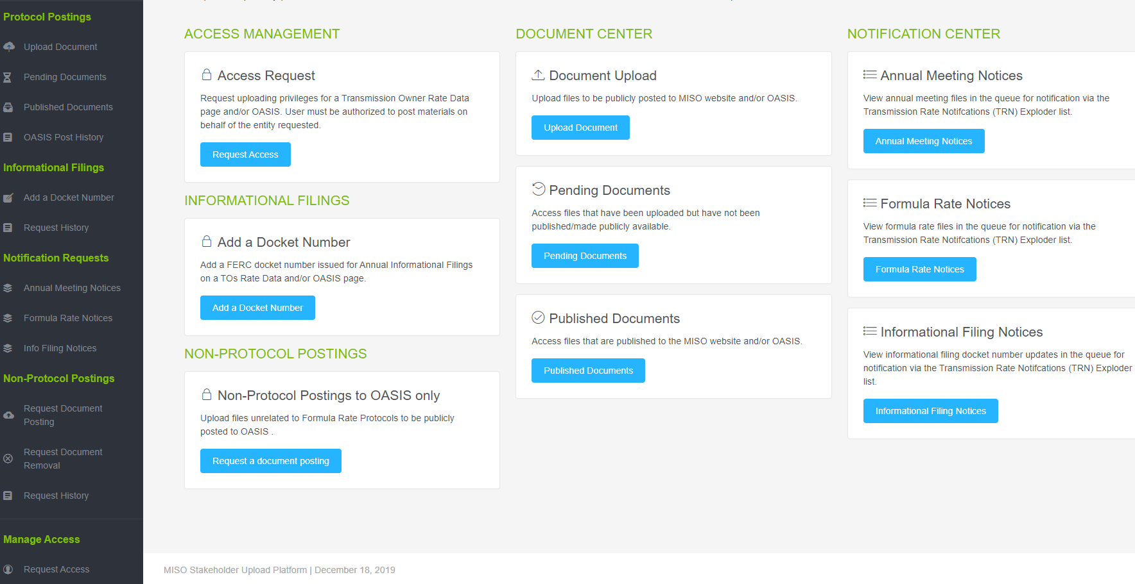

- Check the box to the left of any TO page(s) you need access to, scroll to the bottom of the page & click the blue ‘Request Access’ button.
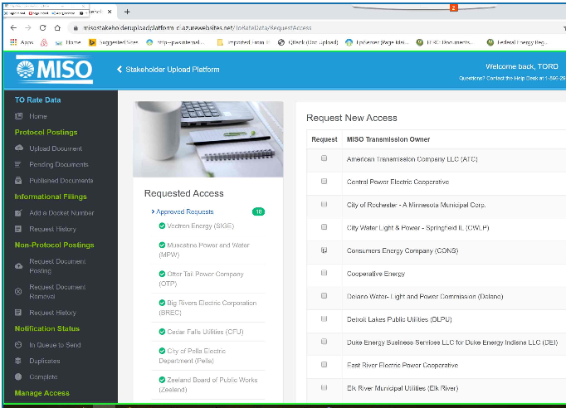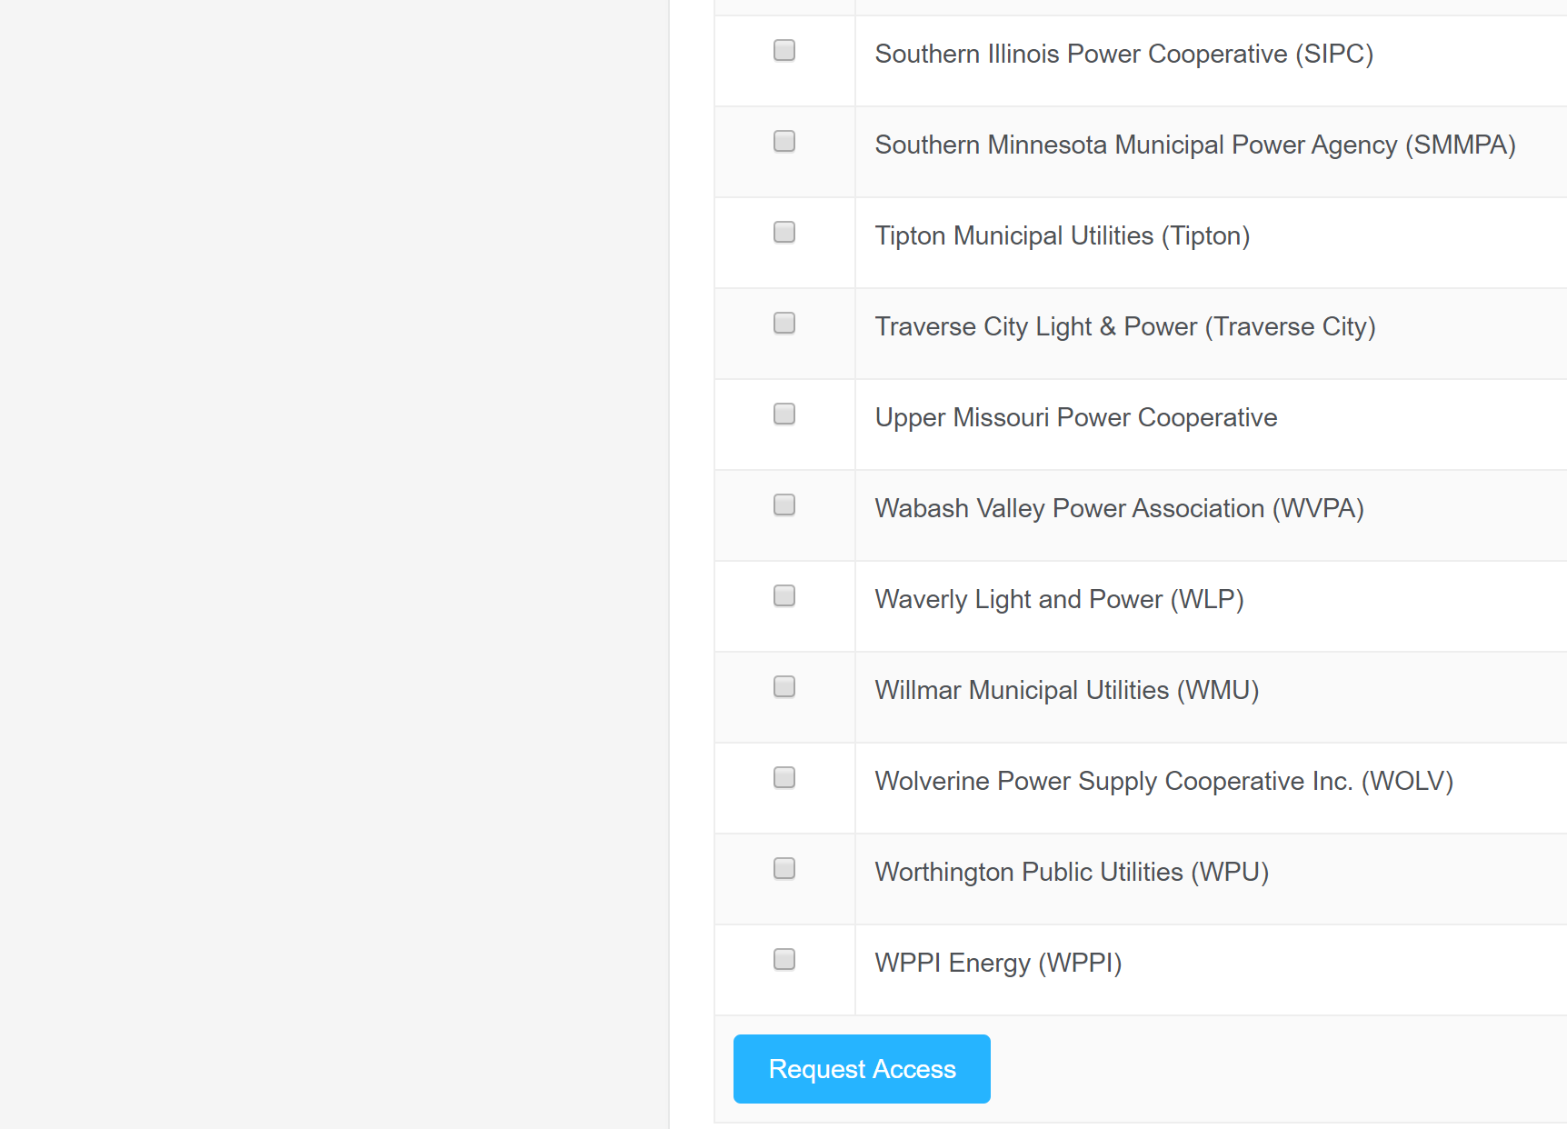

- Your request will be submitted to MISO for review & approval. You’ll receive an email confirmation when approval is complete.

2.3 Platform Menu Overview
Home – view all menu options
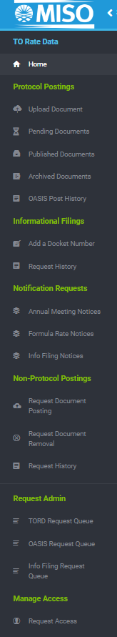

Protocol Postings
Upload Document – upload materials to be posted to the MISO TO Rate Data page and/or OASIS

Pending Documents – documents uploaded, but not yet published to the MISO website and/or OASIS

Published Documents – documents that have been publicly posted to the MISO website and/or OASIS

Archived Documents – documents that are no longer published on the MISO TO Rate Data Page

OASIS Post History – documents that have been publicly posted to OASIS

Informational Filings
Add a Docket Number – submit a request to publicly post the docket number FERC assigns to your Annual Informational Filings

Request History – view status of Informational Filing posting requests

Notification Requests
Annual Meeting Notices – view status of Annual Meeting Notifications for posted materials

Formula Rate Notices – view status of Formula Rate Notifications for posted materials

Info Filing Notices – view status of Info Filing Notifications for posted docket numbers

Non-Protocol Postings
Request Document Posting – ONLY to be used for OASIS postings NOT related to the Attachment O Formula Rate Protocol requirements

Request Document Removal – request removal of a document from OASIS (NOT related to Attachment O Formula Rate Protocols)

Request History – view status of Non-Protocol posting requests on OASIS

Manage Access
Request Access – request posting rights to your TO Rate Data page(s)

3. Formula Rate Protocol Postings
Until you’ve requested & been granted access for a particular transmission owner, you will not be able to perform any functions in this section.

3.1 Uploading Documents
- Designed for single file upload. When posting numerous documents, it is recommended the files be uploaded in a zip file.
- Zipped files should be grouped by Document Type to ensure all required notifications are sent. Document Type options are either Annual Formula Rate Posting OR Annual Meeting Notice & Materials
- Do not upload a zip file that contains both Attachment O Formula Rate materials AND an Annual Meeting Notice. Per the Attachment O Protocols, these require separate notifications. The system will only send 1 notice per uploaded file, based on the selected ‘Document Type’.
To submit materials to be posted on your TO Rate Data Page on the MISO website and/or OASIS:
- Under the ‘Protocol Postings’ menu on the left, select ‘Upload Document’
- Select a File (drag & drop OR click to browse & select).
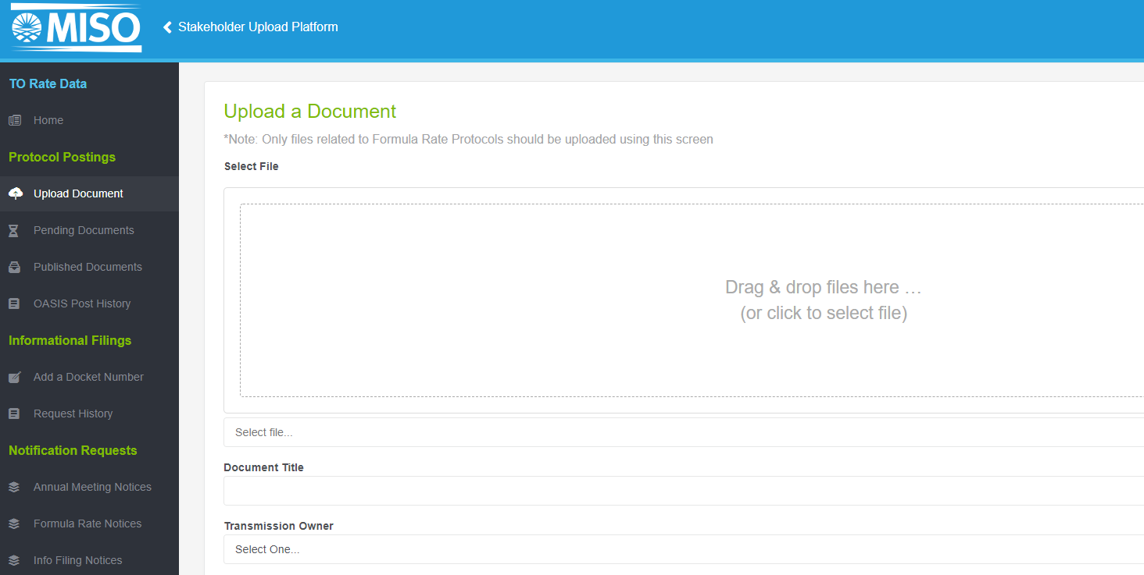

Populate all fields:
  - Document Title is auto-populated from the filename. This can be changed if preferred
  - Select applicable Transmission Owner from the drop-down
  - Choose Document Type
    - Annual Formula Rate Posting (ex. Annual Updates, Annual True-Ups, Projections etc)
    - Annual Meeting Notice or Materials
  - Select Rate Year, if applicable (this field will be greyed out if Annual Meeting Notice/Materials is selected)
  - Choose Posting Location
    - MISO and OASIS (default)
    - MISO Only (to be used if you’ve already self-posted document on your OASIS page)
  - Populate OASIS Navigation as applicable – this should describe where file should be posted on your OASIS page (folder name or other description)
- Read disclaimer & check box to the left.
- Click ‘Upload’. This should be followed by a confirmation that file was successfully uploaded
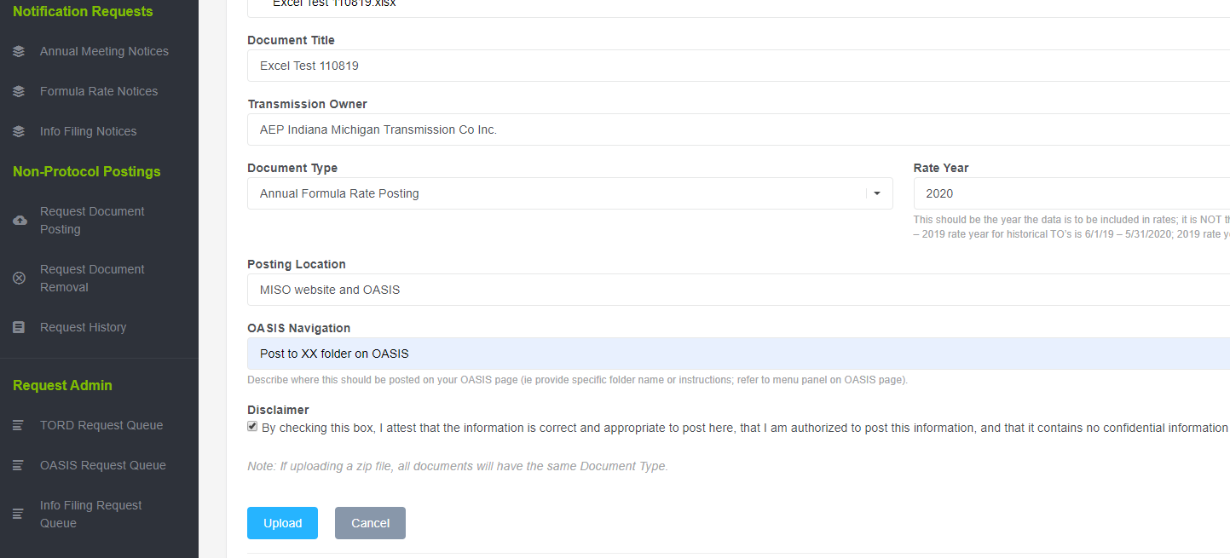

At this point the document has NOT been published. Uploaded (but not yet published) documents can be viewed in ‘Pending Documents’.
Only ‘Published’ documents will be visible on the MISO TO Rate Data page and/or OASIS. There are 2 primary ways to publish a document:

3.2 Publishing Documents
Following confirmation of successful document upload, you’ll have to Publish the document to make it publicly available:
- To publish immediately, select the blue ‘Publish’ button directly under the confirmation message. 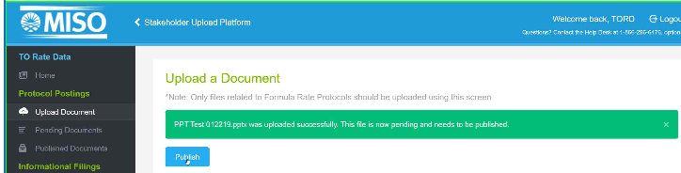

- If you wish to make publicly available at a later time:
  - When ready to publish, on the menu under ‘Protocol Postings’ click ‘Pending Documents’ & locate the file you want to publish
  - Click the blue upward arrow ‘Publish Document’ button in the ‘Action’ column

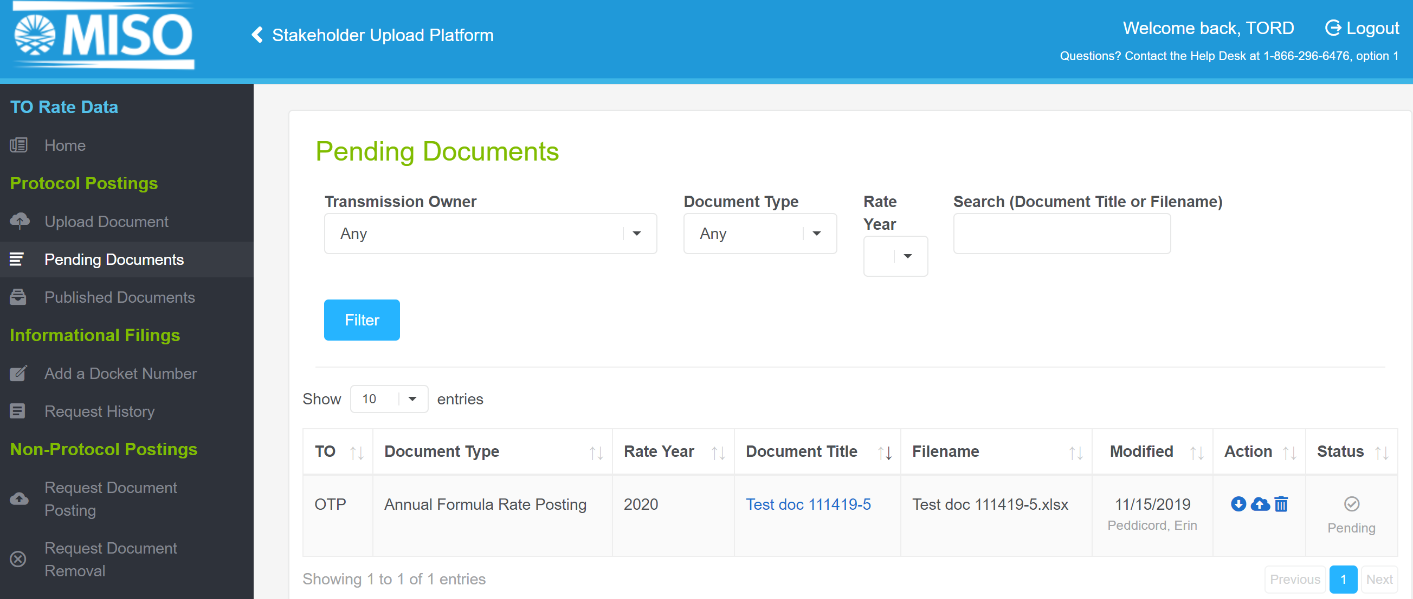

A Notification Requirement pop-up alerts user that a notification will be sent to the Transmission Rate Notifications (TRN) mailing list. This is the last step to complete before a document is published.

3.3 Sending Notifications
To complete publishing your document, you’ll have to confirm (or bypass) the notification. The default setting for all Formula Rate postings is to send the required notifications, however this can be bypassed, if applicable for your particular situation.

- Confirm or alter default notifications
  - To confirm, Select ‘Continue’ – this will Publish document and send the applicable notification to the Transmission Rate Notifications (TRN) mailing list
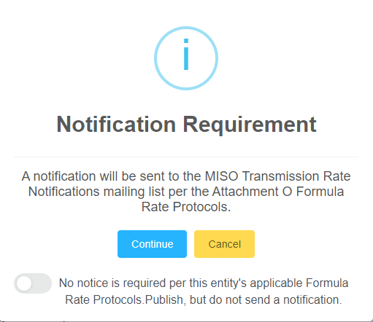

  - To bypass the default notification - If no notification is required per your applicable Formula Rate Protocols, you can move the toggle button to ‘No notice is required…’, then select ‘Continue’. This will publish the document but will NOT send a notification to the TRN mailing list. Consult your applicable Formula Rate Protocols before opting out of notifications!
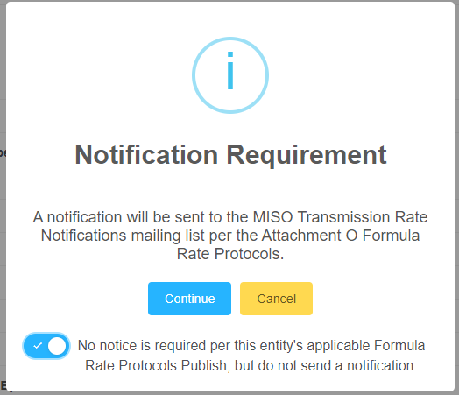

- Either selection above should be followed by a confirmation that file was successfully published.

- Review your posting on the MISO TO Rate data page to ensure your posted document is displayed as desired.

There will be a lag in the postings to OASIS. You should receive email confirmation when OASIS postings are complete. These should be reviewed to ensure they’ve been posted as intended.

3.3 Viewing Documents
- In the Stakeholder Upload Platform
  - Uploaded documents that have not been published/posted can be viewed in the Protocol Postings / Pending Documents
  - Posted documents can be viewed in the Protocol Postings / Published Documents
- On the MISO Transmission Owner Rate Data page
  - https://www.misoenergy.org/markets-and-operations/settlements/to-rate-data/

  - Navigate to your TO page
  - Documents can be accessed using the Navigator menu. Formula Rate postings are arranged by Rate Year. The Annual Meeting Notice section contains annual meeting details and materials.
- On OASIS
  - https://www.oasis.oati.com/miso_default.htm
  - Navigate to your OASIS page
  - Each TO determines how files are organized and stored on their OASIS page – file locations will vary

3.4 Archived Documents
Documents that have been archived will no longer be visible on the public MISO website (only most recent 3 years’ worth of posted materials will remain visible on the MISO TO Rate Data pages). However, users can still access archived documents from within the Stakeholder Upload Platform.
To view archived documents:
- Select ‘Archived Documents’ from the left menu
- 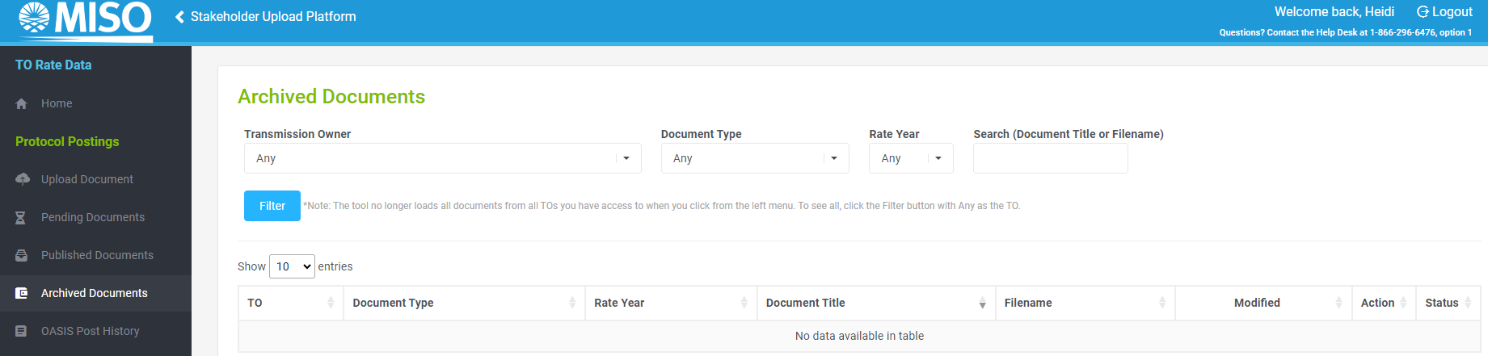
- Select Transmission Owner name from the dropdown menu. (Note: you may also select Document Type and/or Rate Year to further filter your results)
- Click the blue “Filter” button to return a list of all archived documents

3.5 Downloading Files
All uploaded documents can also be downloaded from the platform, regardless of status.

- In either ‘Pending Documents’ or ‘Published Documents’, locate the file you want to download. Select the blue downward arrow icon from the ‘Action’ column to download


- Alternatively, you can download from within the document details screen by clicking on the Document Title, then select ‘Download File’ in the Document Information view.
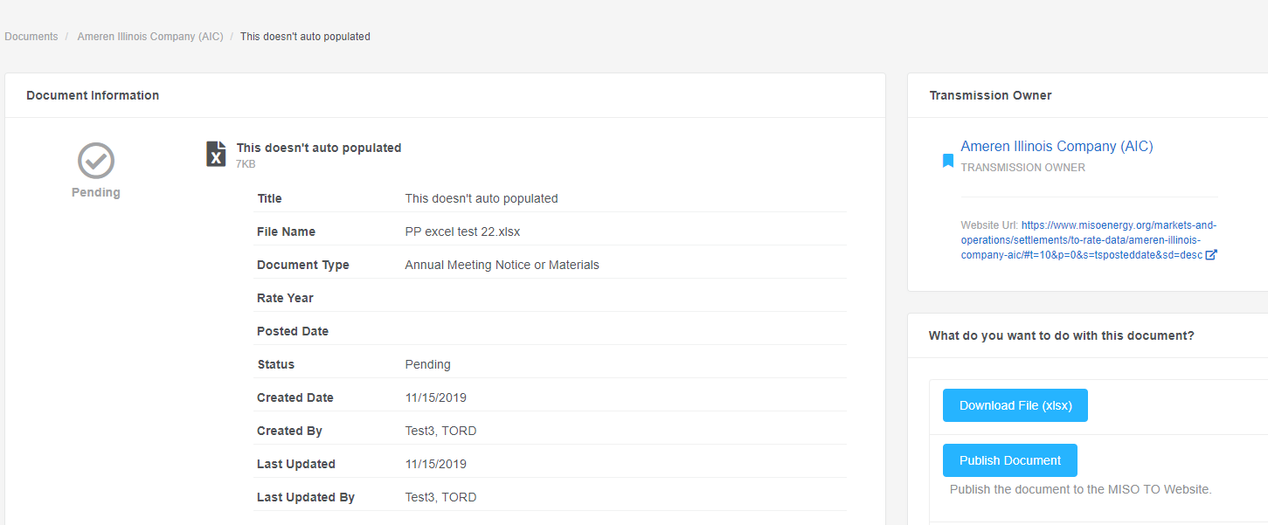

3.6 Deleting Documents
A file ‘replace’ option is currently not in the tool. If you wish to replace a posted document, that document should be deleted, and a new file uploaded.
- Under the ‘Protocol Postings’ tab on the menu, click ‘Published Documents’
- Locate the file that should be removed. There are 2 options to delete a file:
  - Use the trashcan icon in the ‘Action’ column OR
  - Click the Document Title link. In the Document Information screen, click the red ‘Delete’ button in the bottom right corner of the page
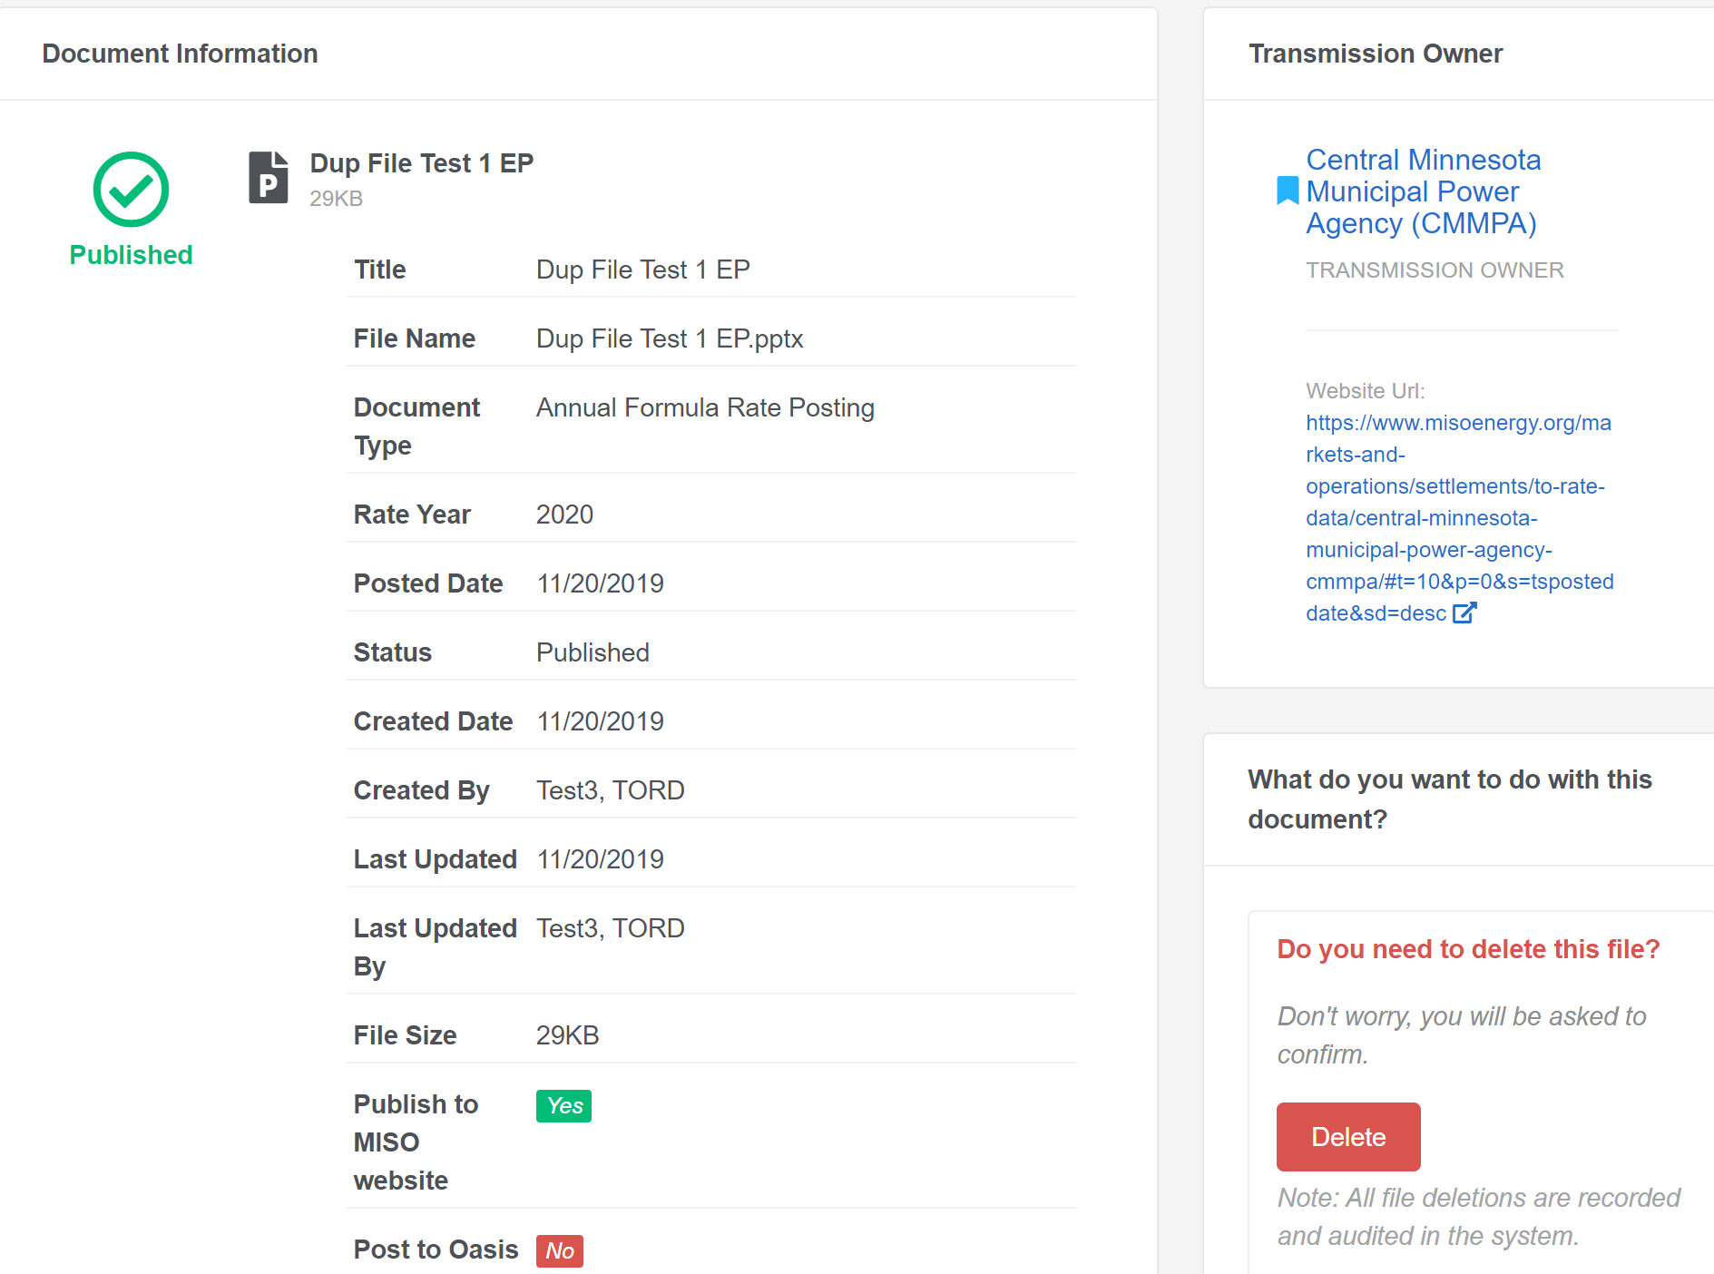

NOTE: A published file that has been deleted in the tool will be removed from the owner’s TO Rate Data page and OASIS, as applicable.

4. Annual Informational Filings
Until you have requested & been granted access for a particular transmission owner, you will not be able to perform any functions in this section.

4.1 Post a Docket Number
- From the Informational Filings menu, select ‘Add a Docket Number’
- Select applicable Transmission Owner from the dropdown
- Choose Posting Location
  - MISO Website and OASIS (default)
  - MISO website only – to be used only by TO’s that self-post to OASIS
- Insert Docket Number provided by FERC for your Annual Informational Filing
- Add posting instructions for OASIS. This should describe where the posting should be displayed on your OASIS page (folder name etc)
- Click ‘Submit’
- After MISO has posted the docket number to the TO Rate Data Page and/or OASIS, an email confirmation will be sent to requester

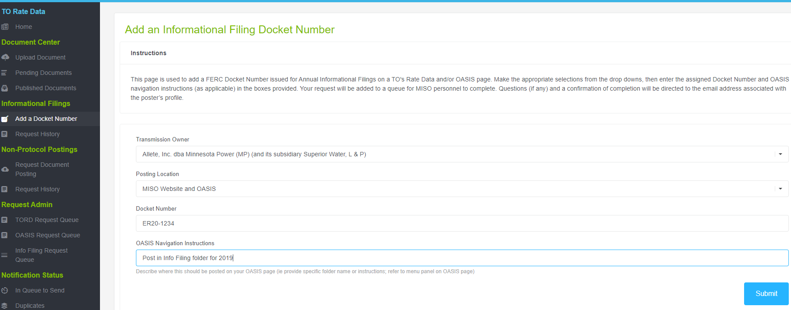

4.2 View Informational Filing History & Posting Status
- From the Informational Filings menu, select ‘Request History’
- Select applicable Transmission Owner from the dropdown (if you manage multiple TO pages)
- Table can be filtered by Transmission Owner or Status (Requested, Pending, Resolved)
- Table columns can also be sorted using the ↑↓ arrows in each column heading & provide information for:
  - Who submitted the request
  - When request was submitted
  - When it was posted to the MISO TO Rate Data page
  - When it was posted on OASIS
  - Current Status
- Additional document details can be retrieved by clicking on the Request ID.

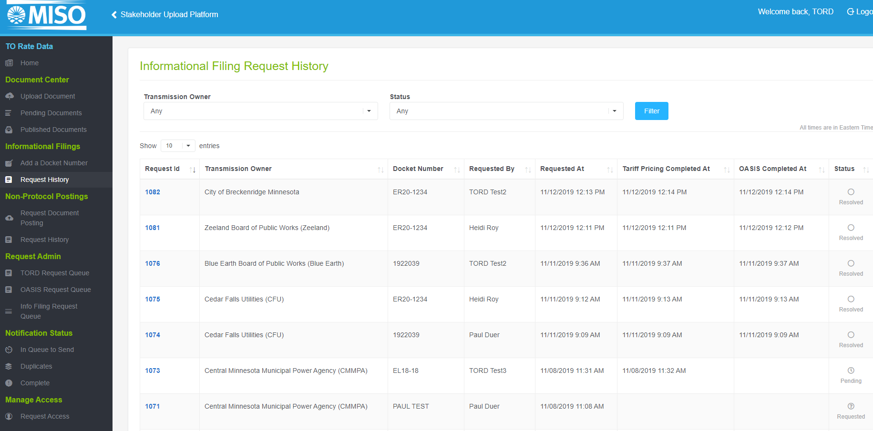

5. Non-Protocol Postings
Until you have requested & received approval for access for a particular transmission owner, you will not be able to perform any functions in this section.

5.1 Request Document Posting
Postings submitted here should not be associated with the Attachment O Formula Rate Protocols or any of its requirements. This should be used for other documents that need posted to OASIS.

5.2 View Request History
Historical posting details can be viewed from this screen. The table can be filtered by TO or status & provides basic information including Request Date & Current Status. Additional document details can be retrieved by clicking on the Request ID.

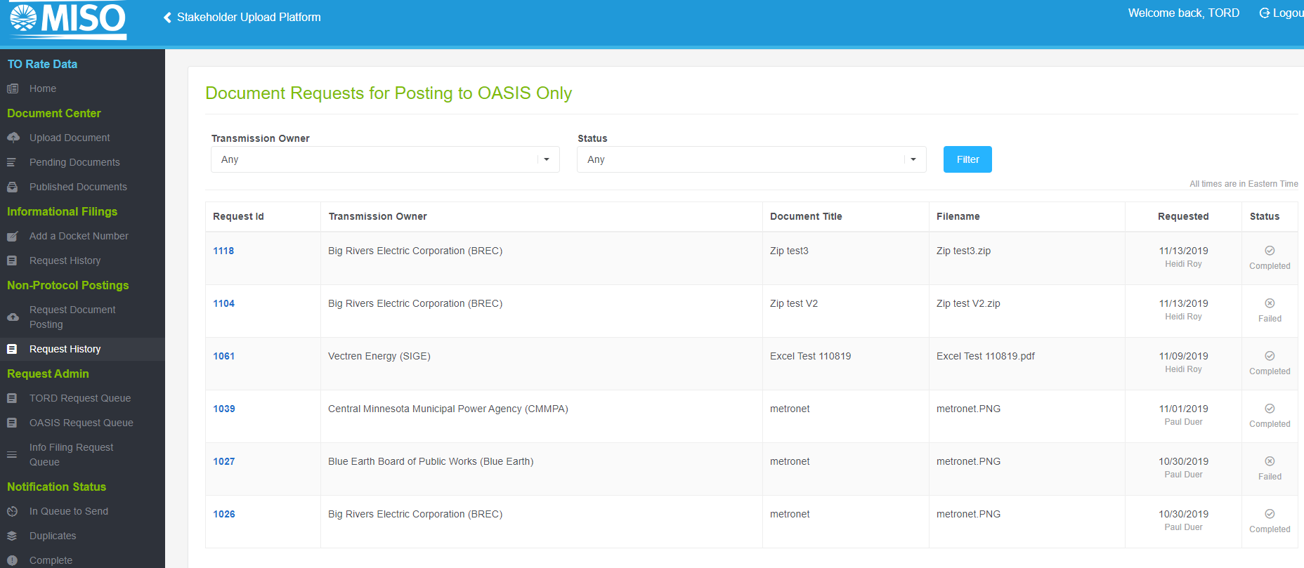

6. Notification Requests
The Attachment O Formula Rate Protocols outline a series of annual posting & notification requirements for entities that submit an Attachment O to MISO for inclusion in transmission rates.
FERC-required notifications are sent to subscribers of the MISO Transmission Rate Notifications (TRN) mailing list, and provide interested parties notice of formula rate postings, annual meetings, etc.
Until you have requested & been granted access for a particular transmission owner, you will not be able to view notification status for that entity.

6.1 Notification Types
- Annual Meeting Notices
- Formula Rate Notices
- Informational Filing Notices
Document details & notification status can be viewed for each type
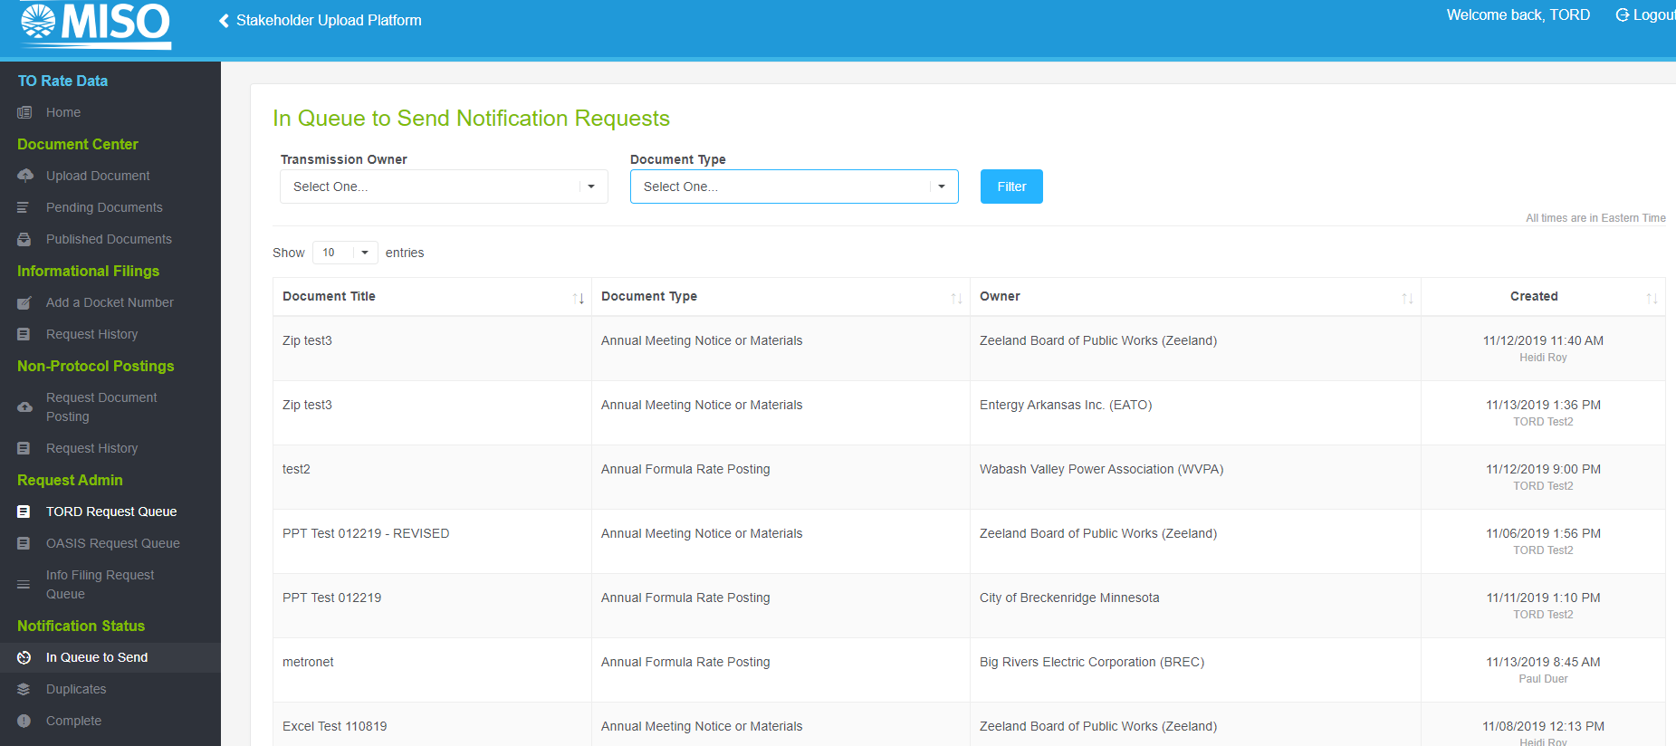

6.3 Notification Distribution
Notifications from all owners will be batched daily by ‘Document Type’ & sent to the Transmission Rate Notifications (TRN) mailing list at the close of business. See Appendix A for instructions on subscribing to the TRN mailing list.

7. Manage Access

7.1 Request Access
Before a transmission owner can submit any posting requests to their TO Rate Data or OASIS page using this tool, an access request must be submitted to MISO. From this screen, you can request access to your TO page(s) and view the status of any access request(s) you’ve submitted.
Refer to Section 2.2 for specific instructions on submitting access requests.

 All employees with Formula Rate Protocol posting responsibilities at your company should complete their access request as soon as possible to avoid any future posting delays.

Appendices

Appendix A: Subscribe to the Transmission Rate Notifications (TRN) Exploder List
This list notifies subscribers of Formula Rate Protocol postings related to the following:
- Attachment O-related annual revenue requirement updates, true-ups, projections
- Transmission owners’ meeting details to discuss Annual Updates, Annual True-Ups and Projected Net Revenue Requirements
- Annual joint meeting on regional cost-shared projects
- Notice of transmission owners’ annual Informational Filings with FERC
- Other notifications upon request

To receive these Formula Rate Notifications, interested parties should subscribe to the Transmission Rate Notifications (TRN) exploder list.
Subscribe to the list
- Navigate to the following page:
https://www.misoenergy.org/markets-and-operations/settlements/to-rate-data/

- Click on ‘Subscribe to Transmission Rate Notification mailing list’

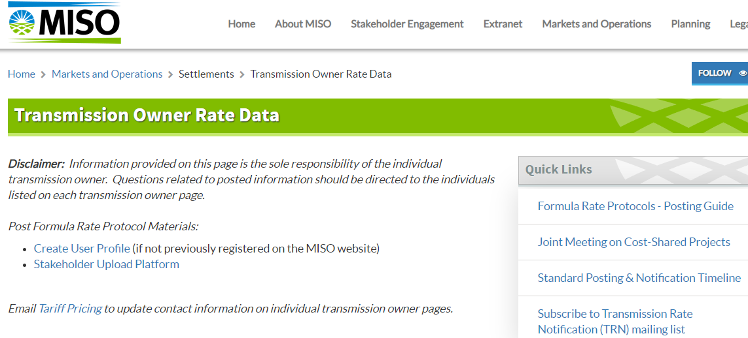

- Login is required to register for MISO mailing list notifications; if you are not an existing user, you must first create a profile on the MISO website.
- While in your profile, scroll down to ‘Mailing Lists’ and select ‘All Available Mailing Lists’ tab.

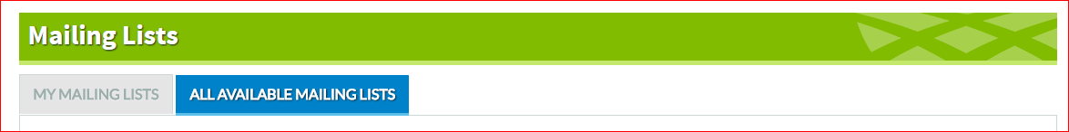
- The list can be found under “Other Mailing Lists” and is called “Transmission Rate Notifications (TRN)”. Screenshot included below.
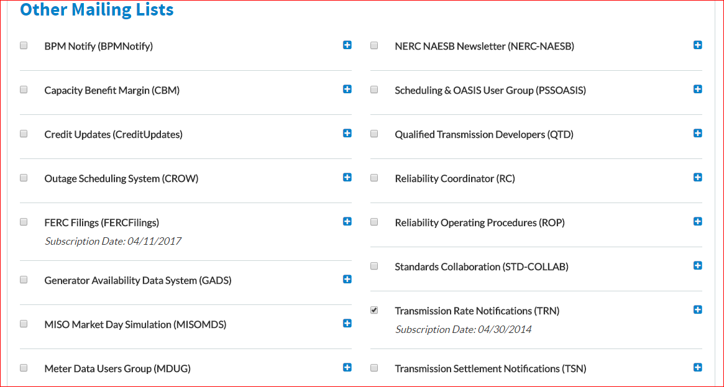
- Subscribers will receive all notifications sent to the TRN list. There is currently no functionality to receive notifications for specific entities.

Appendix B: Attachment O Formula Rate Protocols Background

Background
On May 17, 2012, the Commission instituted a Formula Rate Protocol investigation (EL12-35), pursuant to section 206 of the Federal Power Act to determine whether the formula rate protocols under Attachment O of the MISO Tariff were sufficient to ensure just and reasonable rates. The Commission identified three areas of concern:
(1) scope of participation (i.e., who can participate in the information exchange)
(2) the transparency of the information exchange (i.e., what information is exchanged); and
(3) the ability of customers to challenge transmission owners’ implementation of the formula rate as a result of the information exchange (i.e., how the parties may resolve their potential disputes).
In response to FERCs May 16, 2013 order on EL12-35, the TO group submitted formula rate protocol revisions (ER13-2379) to address the Commission’s concerns regarding scope of participation in, transparency of, and challenge procedures as it relates to the revenue requirements calculated under the MISO tariff.
On 03/20/2014, the protocols were conditionally accepted (subject to further compliance filings which were ultimately accepted 8/21/15), effective 01/01/14. The Formula Rate Protocols lay out a series of detailed timelines and public posting obligations for all parties who submit an Attachment O to MISO, and subsequent notification requirements for MISO.

The sample timeline in Appendix C is MISO’s summary of the “standard” protocols adopted by a majority of the owners in ER13-2379, however many entities have filed company-specific Formula Rate Protocols with timelines that may differ slightly from this example. Each entity subject to the Formula Rate Protocols should consult their applicable protocols for specific requirements and deadlines. The current tariff can be located on the MISO website (Attachment O Rate Formulae/MISO Formulaic Rates).
Transmission owners are responsible for
- complying with the posting & notification requirements of their applicable protocols each year
- Initiating and properly completing all MISO/OASIS posting requests via the procedures herein.

Appendix C: Formula Rate Protocols - Standard Posting & Notification Timeline
Summary of important deadlines for the generic Formula Rate Protocols filed in ER13-2379. TO’s that have filed company-specific protocols may utilize a different timeline. Refer to applicable protocols for those entities.
 | Attachment O Formula Rate Protocols - Important Dates
Tariff  Ref |  | Annual Deadlines | Transmission owner  Posting/Notification  Action Required | MISO  Posting/Notification  Action Required
II.B | June 1 | Publication Date** for Annual Update (hist TO’s) or Annual True-Up (fwd-looking TO’s) postings. (Info Exchange Period and Review Period begin) | Submit posting files to MISO no later than June 1 | MISO to post files upon request. Within ten (10) days of such posting, MISO shall provide notification of posting via the TRN email exploder list
II.E | Between June 1 - September 1 | Deadline for transmission owner to hold annual meeting on Annual Update or Annual True-Up | Submit meeting notice information to MISO no less than 8 days prior to meeting (TO should refer to relevant protocols for their specific dates) | MISO to post meeting notices indicating time/date/location. No less than seven (7) days prior to meeting, MISO shall provide notification of the posting via the TRN email exploder list
 | Between September 1 – October 1 (Forward-looking TOs only) | Deadline for transmission owner to post Projected Net Revenue Requirement | Submit posting files to MISO no later than October 1 (TO should refer to relevant protocols for their specific dates) | MISO to post files upon request. Within ten (10) days of such posting, MISO shall provide notification of posting via the TRN email exploder list
 | Between September 1 – October 31 (Forward-looking TOs only) | Deadline for transmission owner to hold meeting on Projected Net Revenue Requirement | Submit meeting notice information to MISO no less than 8 days prior to meeting (TO should refer to relevant protocols for their specific dates) | MISO to post meeting notices indicating time/date/location. No less than seven (7) days prior to meeting, MISO shall provide notification of posting via the TRN email exploder list
II.F | November 1 | Deadline for joint meeting on regional cost-shared projects | An appointed member of this group should submit meeting notice information to MISO no less than 8 days prior to meeting | MISO to post meeting notices indicating time/date/location. No less than seven (7) days prior to meeting, MISO shall provide notification of posting via the TRN email exploder list
III.A | December 1 | Deadline for Interested Parties to submit information requests
III.B | January 10 | Deadline for transmission owner to respond to information requests | If applicable, submit to MISO information requests from Interested Parties and the owners response(s) to such requests | MISO to post files as received  (No required exploder list notification included in protocols)
IV.A | January 31 | Deadline for Interested Parties to submit Informal Challenges
IV.B | February 28 | Deadline for transmission owner to respond to Informal Challenges | If applicable, submit to MISO Informal Challenges from Interested Parties and the owners response(s) to such Informal Challenges | MISO to post files as received  (No required exploder list notification included in protocols)
VI.A | March 15 | Deadline to submit Annual Informational Filing to the Commission | Submit Informational Filing to FERC; Notify MISO when filed & provide docket number for posting | Within five (5) days of Informational Filing, MISO shall post docket number and provide notification of posting via the TRN email exploder list
IV.G | April 15 | Deadline for Interested Parties to file Formal Challenge at the Commission
** The date on which such posting occurs shall be that year’s “Publication Date.” If the date for posting falls on a weekend or a holiday recognized by FERC, posting shall be due on the next business day.

